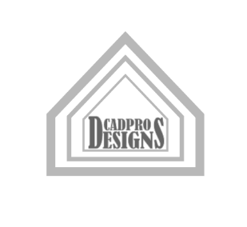
CADPRO Designs— Client Project Intake Form
Thank you for contacting CADPRO Designs. Please complete this project intake sheet to help us understand your design requirements, technical scope, and project goals.

1. Client & Contact Information
- Full Name / Company Name:Click or tap here to enter text.
- Primary Contact Person:Click or tap here to enter text.
- Email Address:Click or tap here to enter text.
- Phone Number:Click or tap here to enter text.
- Project Site Address / Location:Click or tap here to enter text.

2. Project Overview & Scope
- Project Type:Choose an item.
  - Other: ___________________________

Specifications & Software Requirements
- Deliverable Format Preferred:Choose an item.
  - Other: ___________________________

- Standard / Code Compliance:
- Existing Documentation Available:Choose an item.

4. Timeline & Budget
- Target Start Date: Click or tap here to enter text.
- Required Completion / Milestone Dates:Click or tap here to enter text.
- Estimated Budget Range: Click or tap here to enter text.

5. Submission & Next Steps
Please return this completed form and any attachments via one of the methods below. Once reviewed, CADPRO Designs will follow up with a formal proposal, fee estimate, and project schedule.
- Studio Contact: CADPRO Designs | Clover, South Carolina
- Email: tmcdougald78@gmail.com
File Transfer Options: Please select one of the following methods to transfer your files to the CADPRO Design studio. Remember to include the Name of Project and Project deadlines.
- [ ] Email Attachment: Send directly to tmcdougald78@gmail.com (for smaller files/PDFs)
- [ ] Google Drive Access: Share folder/files with tmcdougald78@gmail.com at Google Drive
- [ ] FTP Site: Upload to designated CADPRO FTP server (send a request by email)
- [ ] Other: Click or tap here to enter text.

